Microbiology
Classification and Taxonomy

- They are diverse and live everywhere you can possibly imagine.

  - Bottom of the ocean
  - High in the atmosphere
  - Hot environments
  - Salty environments
  - In us and on us!

- Some hurt us, make us sick, and even kill us. Others help keep us healthy and provide for many of the products we rely on daily
Why are names important?
Taxonomy – the science of classifying organisms. Useful in determining relationships and similarities between organisms.
Carolus Linnaeus
- the “Father of Modern Taxonomy”
- grouped organisms according to structural similarities
- named organisms in Latin language (common language of the day)

6 Kingdom System

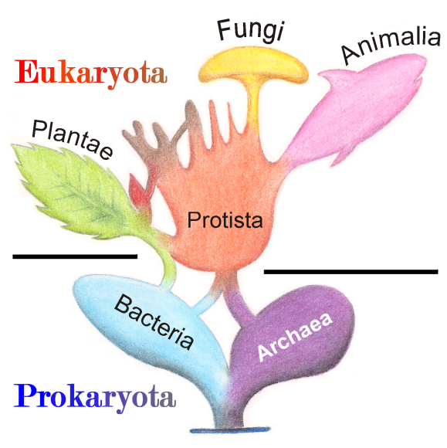

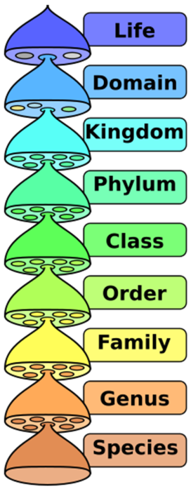
- Organisms are grouped into smaller and smaller
groups all the way down to their species based on
common characteristics
- A species is the most specific grouping and
includes only organisms that can interbreed with
each other and produce fertile offspring.

Binomial Nomenclature – name given to each species as identification
- A two-name system
First part of name: genus
- (first letter is always capitalized)
Second part of name: species
- (First letter is always lowercase)
Entire name is underlined and italicized
- Names must be submitted for acceptance by original discoverer and are generally Latin or Latinized – often reference species characteristic, geography, discoverer…)
Ex. American Black Bear –
House Dog -
Wolf -
Human Classification

Domain:
Kingdom:
Phylum:
Class:
Order:
Family:
Genus:
Species

