SBI3C – Cellular Biology Unit Test Review
LT#1: I can compare and describe how plant and animal cell organelles support the life of the cell.

- Cell structure – compare plant and animal cells, how are they the same, how are they different
- Cell organelles – create a list of organelles, compare between plants and animals, which are the same, which are different; which organelles are the most important to support the life of the cell

LT#2: Using the fluid mosaic model, I can describe how substances can be transported across the cell membrane indifferent conditions to support homeostasis in all living things.

- Draw and label the structures of the phospholipid bilayer. Why are they important for the life of the cell (structure/function)?

- Compare and contrast all the types and characteristics of passive and active transport. How are they similar and how are they different?

- Be prepared to describe what happens to the balance of fluids across the cell membrane when you eating something salty. Identify homeostasis being isotonic, describe hypertonic and hypotonic and return to balance of isotonic.

LT #3: I can describe the importance of nutrients (carbohydrates, proteins, lipids) in the human body. I can defend the importance of balanced nutrition to support homeostasis of the body.

- Create a chart and compare all three macromolecules studied: carbohydrates, proteins, lipids.

- Identify their: structural subunit, how they are formed to a macromolecule, their function in the body and at least two examples of each in the body.

- Defend why you would like to rearrange Canada’s food guide based on your knowledge of structure and function of the macromolecules studied to support homeostasis of the body.

LT#4: I can describe the importance of the role of enzymes in the body and under what conditions enzymes work efficiently.

- Describe what the human body experiences when for someone who is lactose intolerant at the enzyme level, using appropriate terminology: substrate, active site, enzymes, disaccharide, monosaccharide, lactose, galactose, glucose, active transport, microvilli, small intestine. What symptoms does this person experience if they ingest lactose?

- Under what conditions (temperature, pH,) do enzymes work efficiently?
- What is denaturing and what does that mean for the enzyme?

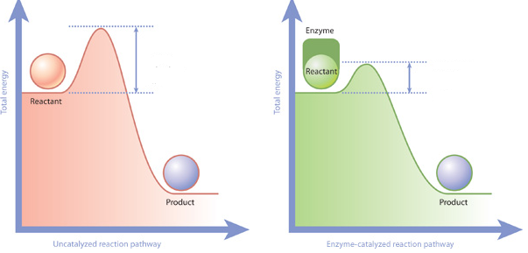

LT #5: I can compare the reactants and products of cellular respiration and their impact on homeostasis of the cell and body as a whole.

- Draw the chemical equation for cellular respiration. Compare the reactants and the products of cellular respiration to that of photosynthesis.

- Describe the molecule of ATP and why this molecule is considered the “energy currency” of the cell.

- Compare the efficiency of aerobic respiration to anaerobic respiration.

