SBI 3C1 Pig Dissection Worksheet #1

Part 1 Introduction and External Anatomy – page 344 -345

Why are pigs useful in understanding how the human body works?

- Use the diagram below to label the external anatomy of the pig:

Nose/Nares
Tongue
Ear
Shoulder
Elbow
Wrist
Digit
Umbilical cord
Hip
Knee
Ankle
Digit
Tail
Nipples
Eyelid

Head Region
Trunk Region
Tail Region

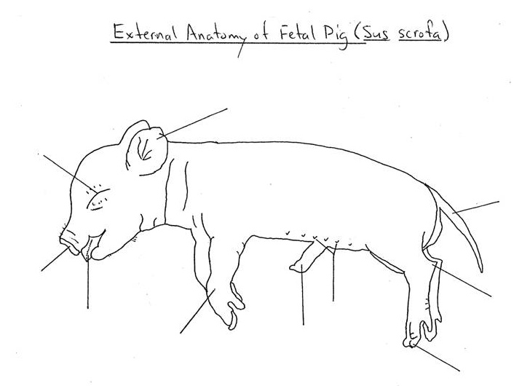

- Use old 3C text page 256-257 to describe how the sex of the fetal pig can be determined
  - For a male.

  - For a female.

- How long is the gestation period (pregnancy) of the fetal pig (use graph on page 344)?

  - Estimate the age of your pig

- As a group determine what is the function(s) of the umbilical cord?

- True or False Only female pigs have nipples?

