SBI3C – Mutations

Mutations are a change in the _____________sequence of DNA. Mutations that occur in the __________cells are not passed onto their offspring. However mutations that occur in the ________ are passed onto their offspring.

Protein Synthesis
Proteins are synthesized (made) by the following process in your cells.
1. The DNA is unzipped and enzymes make a copy of one strand of your DNA. This copy is called messenger RNA or mRNA.

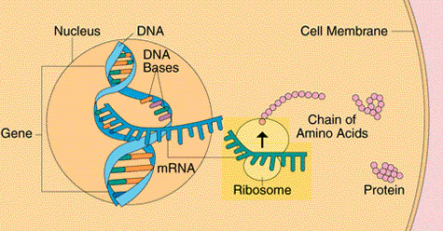
2. This single stranded mRNA copy is thin enough to leave the nucleus through the nuclear pores found in the nuclear envelope.

3. The ‘mRNA’ strand lands on a ribosome, which reads the nucleotide sequence (ie. ACTGTTACGGTA...)
Remember the pairing sequences A=T...G=C etc.

4. Every 3 nucleotide sequence is considered a codon. Each codon is a code or translates by the ribosome into a specific amino acid sequence when read from the ‘mRNA’. Except the nucleotide “T” is replaced now with “U”.
e.g. GUA = valine GGC = Glycine etc.

5. This amino acid sequence is the primary structure (of the four folding steps) of a functional protein.
Let’s practice: Record the correct mRNA strand from the parent DNA below.

DNA: G A U C C C T G T T A G C A T C T G A G G A A T C T T A C C C A A T C T A G

mRNA:

translated:

amino acids:
This is the primary structure for a functional protein in your body.

Mutations: Harmful or Helpful?
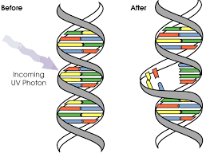
Many mutations happen regularly and are harmless or neutral. Our body naturally autocorrects with enzymes. However! Some mutations can be caused by chemical or UV radiation or other environmental concerns.

Some types of skin cancers and leukemia are caused by mutations in somatic cells. Some mutations improve and organisms chance of survival! ie 6th thumb for panda!

Types of Mutations: Chromosome

This involves changing the structure of the chromosome either by losing or gaining part of a chromosome. There are 5 types: deletion, inversion, translocation, nondisjunction, duplication. Please sketch a brief example of each:

Deletion is due to a breakage,
a piece of chromosome is lost.

Inversion, piece of chromosome breaks off
flips over and reattaches.

Duplication is where a sequence is duplicated.

Translocation two non-homologous chromosomes
exchange sections. ie chromosome 4 & 20.

Non-disjunction is the failure of chromosomes to separate correctly during meiosis. Results in too many chromosomes (trisomy 21) or too few (X0).

Types of Gene Mutations (5)

Point Mutation is a change in a single nucleotide either by deletion, insertion or substitution of ONE nucleotide in a gene. (ie Sickle Cell disease, point mutation on the hemoglobin gene)

Frameshift Mutation is the insertion or deletion of one or more nucleotide sequences that changes the ‘reading frame’ for codon reading. (ie changes the amino acid structure = change in protein structure) (ie Cystic Fibrosis, protein structure change results in improper functioning).

