Animal Structure and Function - Homeostasis
Learning Target #1:
I can describe how the body is organized and maintains homeostasis.

- Specialized cells (structure) that perform a specific function.
- Trillions of specialized animal cells work together to form tissue
- Specialized tissues work together to form organs
- Organ systems work together to support life of the entire organism
- Supporting life involves maintaining homeostasis (dynamic life balance).

Points to Remember in Biology: Structure always matches function.
E.g. compare your skin cells from your fingernail cells
E.g. compare your blood cells from your bone cells

Levels of Organisation
In Animals

There are 11 Main Systems in the Body

Function in Organism | System Name | How
Communication | Endocrine  Nervous | Produces hormones
 |  | Detects, interprets, responds
Acquire Energy | Digestive  Circulatory  Respiratory | Ingests, digests, egests food
 |  | Transports substances throughout body
 |  | Oxygen inhale, Carbon dioxide exhale
Support and Movement | Skeletal  Muscular | Bones, ligaments, cartilage  Skeletal, smooth and cardiac muscle
Protect the Body | Urinary  Integumentary  Immune & Lymphatic | Filters, excretes waste (controls, water, pH and blood pressure)
 |  | Skin, hair, nails (protection, temperature, water)
 |  | Infection, injury and cancer
Reproduction | Reproductive | Male and female

Homeostasis – Dynamic Balance in the Body
- Your body maintains a healthy functioning temperature of 37ºC.
- The pH of your blood stays near 7.4
- The amount of glucose in your blood stays near a concentration of 100 mg/mL (0.1%)
- The ability of the body to maintain a stable, constant, balanced internal condition, relative to the external environment is called homeostasis
- If a body or organ system cannot maintain this it may stop functioning, or even die.

*Negative Feedback Loop example:
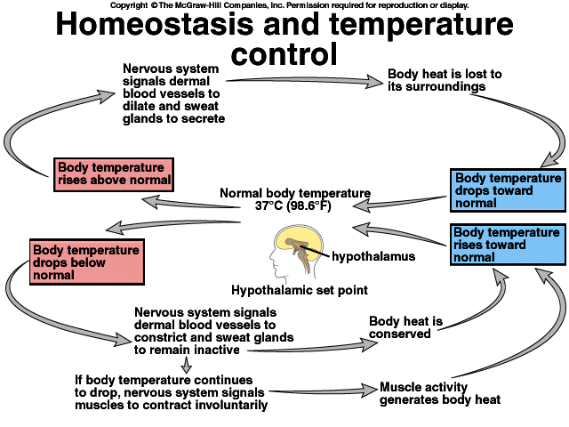

Practice....

- Give your own example of how structure matches the function of an object.
- Choose any 2 body systems and describe one way that their functions are connected to each other. Provide 2 different examples.
- Explain how shivering and an increased heart rate are both examples of homeostasis.
- Why might an organism die if one or more of its organ systems cannot maintain homeostasis? Think of a disease and how it affects homeostasis.

