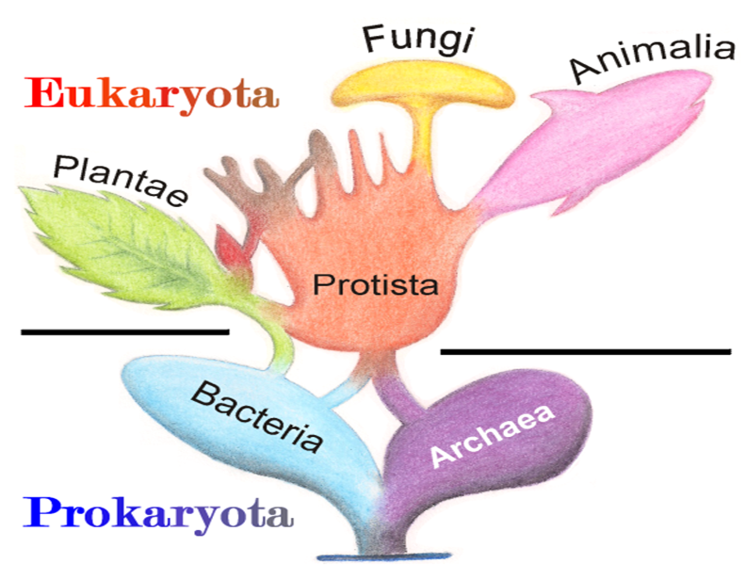
SBI 3C - Harmful or Helpful Microorganism

Prepare a report/presentation/play/rap/(alternate approved by the teacher) for a disease, ailment or benefit, caused by a microorganism that is related to the human body. You must include references to show where your research came from. Also include:
  - Description of disease
  - What parts of the body are affected.
  - Name of organism that causes the disease/benefit
  - Treatment of the disease.
  - How the disease/benefit is passed from person to person
  - Interesting facts/Historical significance of disease or benefit (how was it discovered?)
  - Connections and links between all four units studied in this course so far (* very important!)
0-4 | 5-6 | 6.5-7.5 | 8-9 | 9-10
Report does not demonstrate an understanding of the material  Analysis is not presented in a suitable manner to achieve a passing grade | Report shows little understanding of content and communicates with few of the proper terms  Analysis is poorly written with incomplete sentences and many grammar errors | Report shows some understanding of content and communicates with some of the proper terms  Analysis is adequately written but has incomplete sentences and several grammar errors | Report shows a high level of understanding content and communicates with many of the proper terms  Analysis is well written with full sentences and few grammar errors | shows an excellent level of understanding content and impact on society and communicates with proper terms  Analysis is very well written with proper sentences and grammar
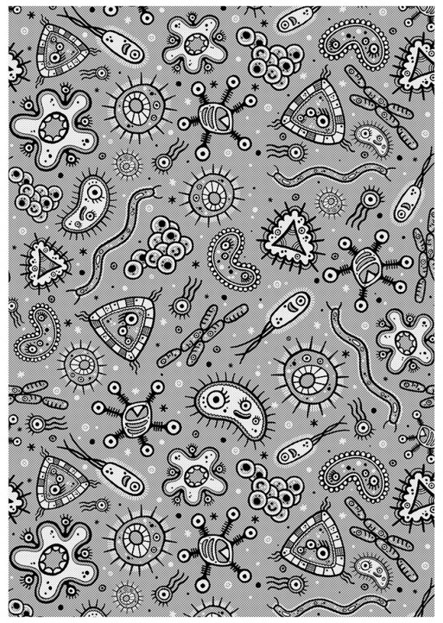
Brainstorm Your Ideas here:

Case Study: Harmful Bacteria
The Walkerton Tragedy
Assignment:
- Read textbook page 118-119
Analysis
- Summarize what happened in Walkerton in a well formed paragraph.

- Describe the symptoms of E.coli 0157:H7 poisoning.

- List the sources of E. coli 0157:H7 contamination.

- Create a graphic organizer for Table 1 (page 119). Draw the three basic bacterial shapes in the centre of a piece of paper. Working out from the middle, name each pathogen and the diseases it produces. (Additional information: clostridium, coliform, and pseudomonads are rod-shaped bacteria.)

- Explain how E. coli contamination can be prevented by the government, and by the population.

